**Team Members:**

Selden Tenzing

Joshua Velez

Kingsley

We were presented with the question:

**What suggestions do you have for success?**

In response to the VP of Sales' goal of improving this year's performance, we have identified several key areas within our shipping processes that warrant optimization. By closely analyzing shipping data and implementing targeted strategies, we aim to minimize delays, enhance customer satisfaction, and ultimately drive sales growth.

In addition to optimizing shipment procedures, we can continue to focus our products and goods to our largest and second largest consumer markets in New York, specifically within Brooklyn, The Bronx, and Manhattan.

Finally, we recommend a marketing campaign for products that are popular in specific regions, and offer seasonal discounts.

With a sample size of 100 orders placed between January 1, 2016, and June 1, 2016, we have identified key areas for enhancement to drive sales growth and improve customer satisfaction.

**Data :**

Our plan is to begin by closely analyzing our shipping data to identify patterns and trends contributing to late deliveries and cancellations. Determine key areas for improvement such as streamlining fulfillment procedures, enhancing inventory management, or optimizing delivery routes to minimize delays and errors.

Our first priority is to analyze our shipping data comprehensively to identify patterns and trends contributing to late deliveries and cancellations. This analysis will enable us to pinpoint key areas for improvement, such as streamlining fulfillment procedures, enhancing inventory management, and optimizing delivery routes. By addressing these inefficiencies, we can minimize delays and errors in the shipping process, resulting in improved customer satisfaction and increased sales.

**Tables:**

Table 1: Number of orders delivered late (87)

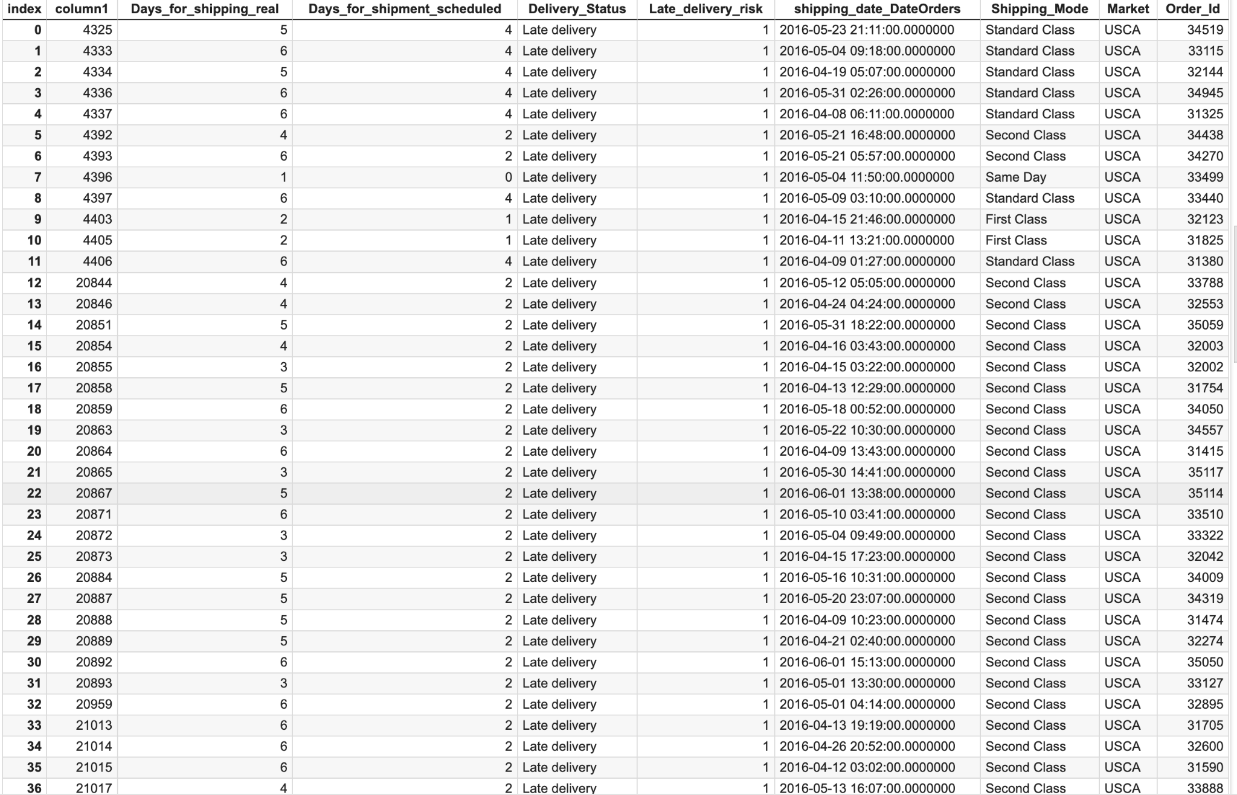

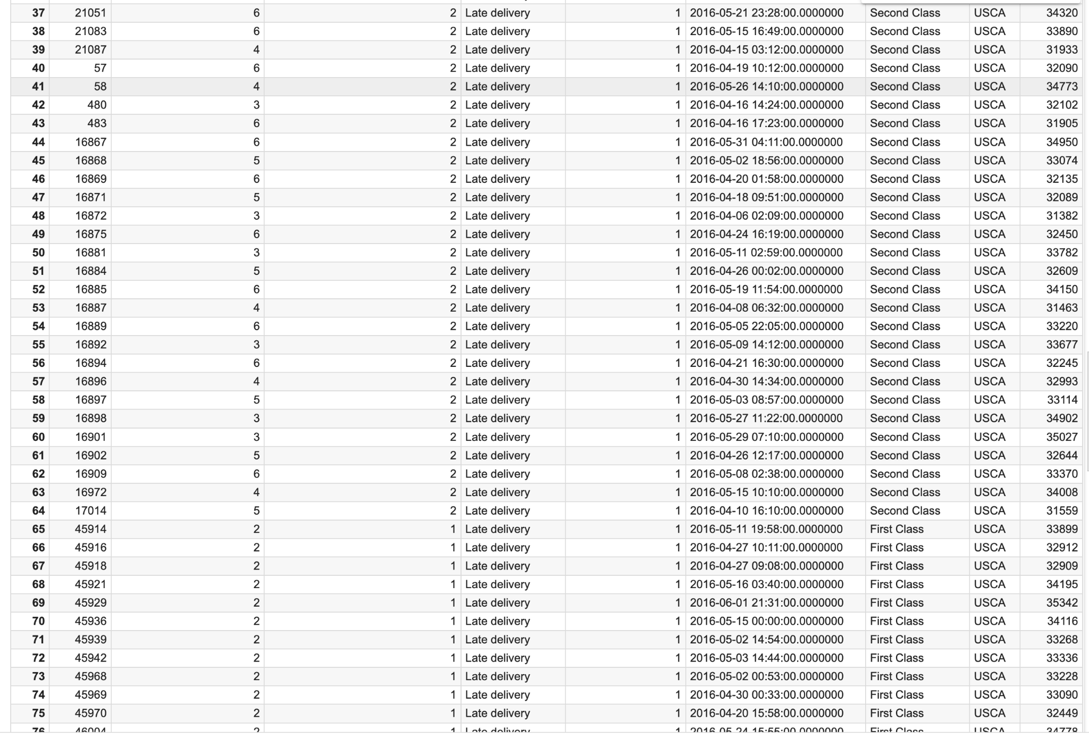

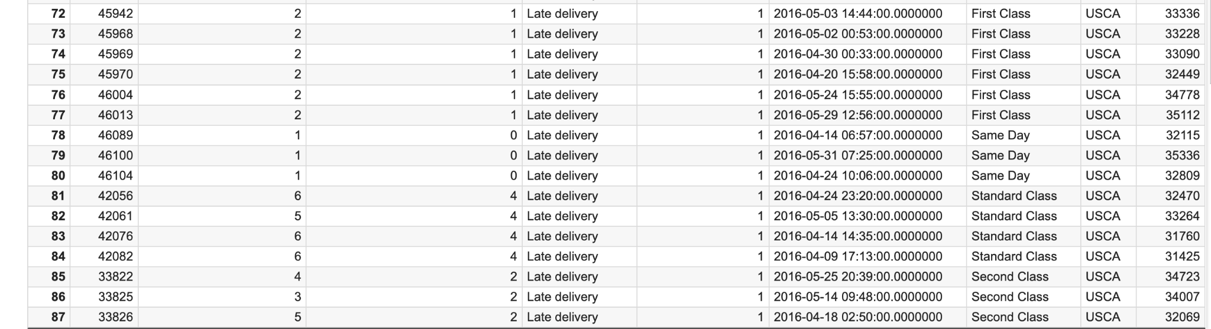

Table 2**: Number of orders canceled (11)**

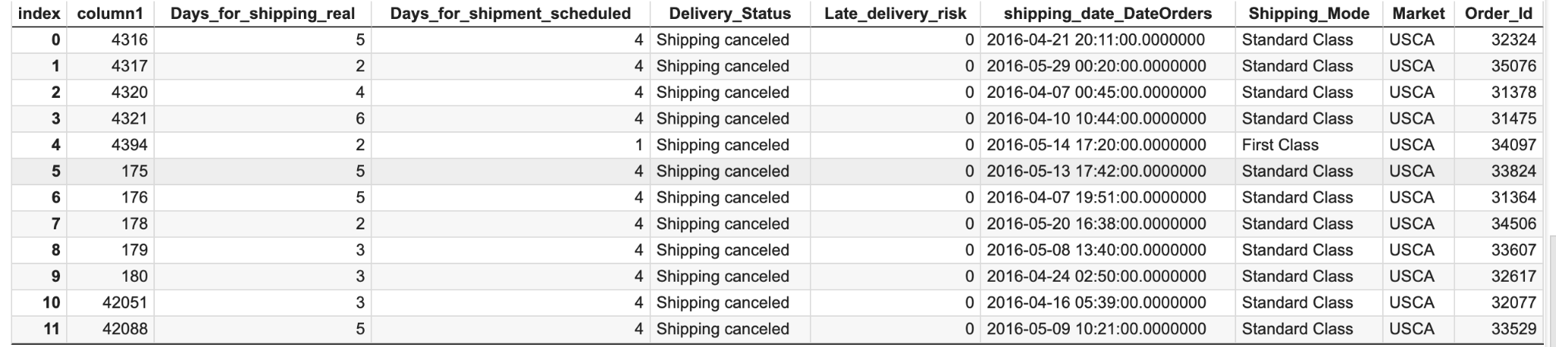

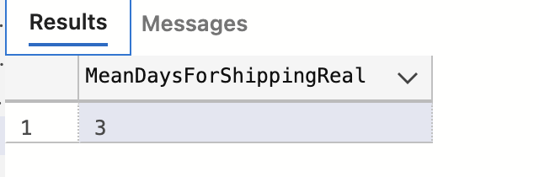

**Graphs :**

Table 1: Customer Demographic based on location in the State of New York.

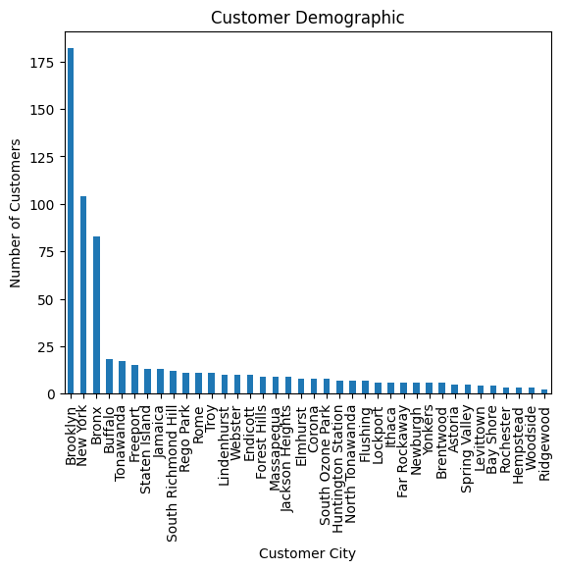

Table 2: Number of fulfilled orders in New York State.

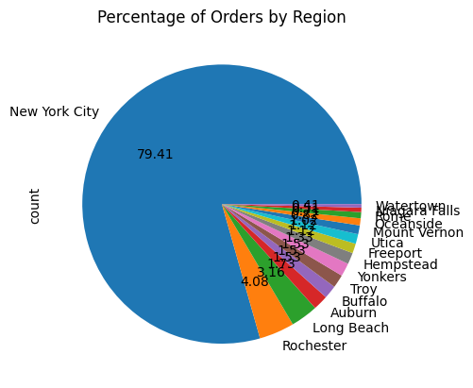

Graph 3:

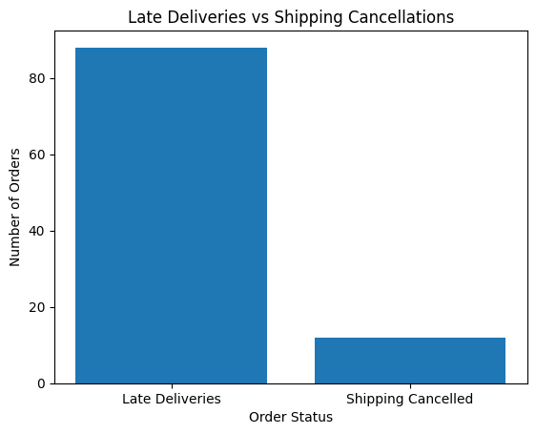

Graph 4:

